HEALTH SELECT COMMITTEE - HEALTH (WATER FLOURIDATION) AMENDMENT BILL

Please be advised that we oppose this Bill

INTRODUCTION:

Educate Don’t Fluoridate is a Nelson, Tasman, Golden Bay, Marlborough group with a database and a Facebook page with four hundred and fifty supporters resident in the Nelson Marlborough region.

We support the topical application of fluoride and the establishment of a comprehensive oral health education programme that will not only address tooth decay but will also reduce the incidence of obesity, diabetes and other chronic conditions.

Educate Don’t Fluoridate opposes the use of our public water supplies to administer a systemic treatment.

HEALTH (FLUORIDATION OF DRINKING WATER) AMENDMENT BILL:

We oppose the transfer of decision making powers from local Councils to District Health Boards. The Minister of Health is the key stakeholder for both elected and appointed representatives on our District Health Board. Bound by Ministry of Health policies and the lack of provision of balanced scientific evidence board members are by default conflicted and under resourced. The result of this is that they are challenged in making well researched decisions about a complex topic such as water fluoridation.

The Bill’s narrow focus on costs v benefits is entirely self serving and fails to address the costs people will face if they do not wish to have fluoridated water (see Freedom to Choose below). We oppose the penalties for Councils for non compliance within the Bill. These penalties are not a penalty against Councils they are a penalty against the people in this case ratepayers. Councils are required by law to consult as a requirement of their Significance and Engagement Policy and as part of their Annual and Long Term planning process. We fail to understand how the provision within this Bill for District Health Boards to direct Councils to fluoridate their water can bypass a consultation process by which Councils are legally bound.

Educate Don’t Fluoridate supports the use of locally run binding referenda for a decision as to whether or not to fluoridate a community. Along with being ethical and moral, binding referenda embraces democracy. Water is a prime necessity for life and it is not the function of a democratically elected government to compel residents to ingest a chemical that is not required for the purification of water.

THE ALTERNATIVE TO FLUORIDATION:

Educate Don’t Fluoridate supports the establishment of a New Zealand tailored comprehensive oral health education programme based on the successful Nexo (Denmark) and Child Smile (Scotland). In 2015 the W.H.O. announced that Denmark had the lowest rate of dental caries in the world. The Danish Nexo programme began in 1980. Its results were so dramatic it then spread to the rest of Denmark.
Tooth decay for five year olds 1980-2004 comparing Nexo with the rest of Denmark:

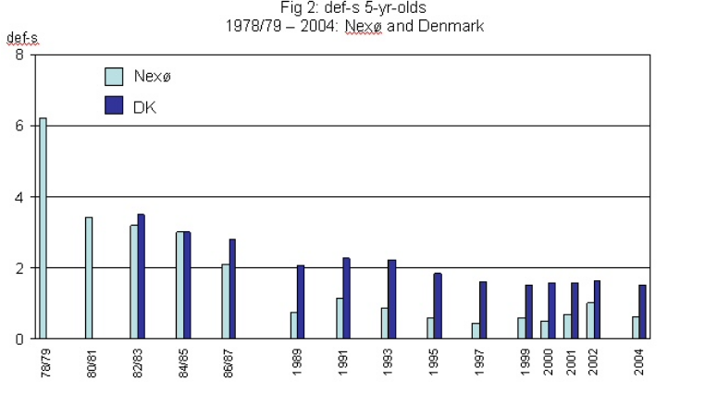
Tooth decay for 15 year olds 1986-2004 comparing Nexo with the rest of Denmark:

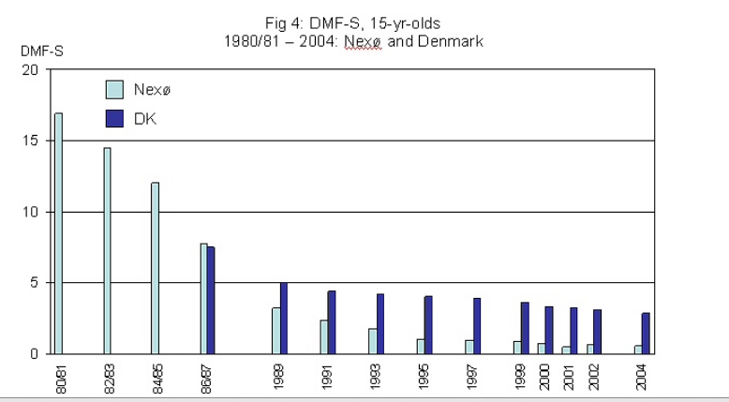

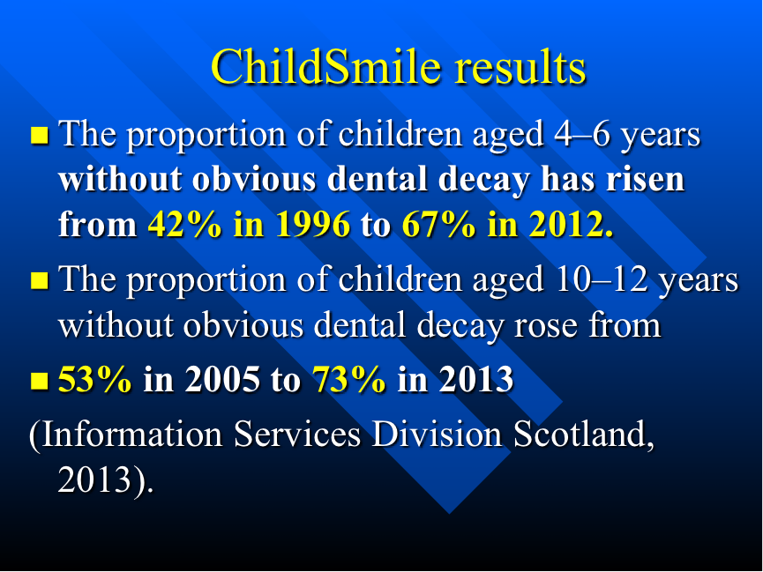

Denmark and Scotland have never fluoridated their water.

Quote from Professor Gregory Seymour retired Dean of the Otago Dental School 2013 “the primary benefit of fluoride is post eruptive and topical.”

THE FREEDOM TO CHOOSE:

Mandatory water fluoridation violates the right of an individual to choose what they ingest. Unlike chlorine, fluoride can only be removed from a water supply with expensive filtration methods. Any legislation designed with the intention to force an individual to ingest fluoride against their will must be accompanied by the right of the individual to opt out and for funding to be made available to the low income sector of our communities (those who have community services cards) to purchase, maintain and install a filtration system that removes fluoride from their household water supply.

THE USE OF A CHEMICAL FOR A HEALTH TREATMENT THAT IS NOT PHARMACEUTICALLY GRADED:

Fluoride added to drinking water is not the naturally occurring calcium fluoride sometimes found in water. It is toxic industrial waste obtained from the emission chimneys of fertilizer and aluminium plants when two toxic gases (hydrogen fluoride and silicon tetrafluoride) are captured in a water spray. The resulting liquid or powder is classified as hazardous waste under the Hazardous Substance Regulations 2001.

Due to the presence of heavy metals in this industrial waste it is negligent to add this to drinking water without compulsory screening and batch testing. Any legislation to add fluoride to our water must include a clause that will give the public confidence that heavy metals have been removed. Fluoride added to toothpaste and in tablet form is pharmaceutically graded and this must be a minimum requirement in the legislation for its addition to drinking water. No levels of lead, arsenic, mercury or uranium are acceptable in local government supplied drinking water.

CONCENTRATION VERSUS DOSE

Trusted health professionals assure the public there are no risks to health at concentration levels of 0.7 - 1.00 ppm. In doing this they fail to inform the public about dose and dosage. For every one litre of water that is consumed at a concentration of 1.00 ppm one mg of fluoride is ingested.

Many individuals such as bottle-fed infants, children under eight years, people with impaired kidney function and people who drink a lot of water such as athletes, manual workers and diabetics will exceed the minimum risk level (MRL) at 0.05 mg/kg/day.

The focus of the Bill is solely dental health and it fails to address the need to monitor for excess accumulation of fluoride in other parts of the body.

MAORI AND PACIFIC ISLAND CHILDREN

The high incidence of kidney disease, diabetes and poor nutrition in our Maori and Pacific Island population places them at greater risk of being negatively impacted by fluoride. New Zealand studies have identified that 30% of children in fluoridated areas suffer from dental fluorosis. Dental fluorosis is an indication of over exposure to fluoride from a number of sources. Studies show that dental fluorosis impacts black and Hispanic American children more than white children (Centre for Disease Control survey). To claim that this is cosmetic negates the psychological impacts on children and ignores the fact that this is indication of a systemic effect that has caused an alteration to the biochemistry of the growing tooth.
RSNZ REVIEW 2014
The Ministry of Health places a strong emphasis on the content of the Royal Society of New Zealand 2014 review conducted by Professors Gluckman and Skegg.
This review took three months to complete and had a budget of $50,000. Comparative reviews have taken up to three years and cost in the millions of dollars.
In correspondence between Professors Skegg and Gluckman obtained under the Official Information Act Professor Skegg stated “the literature on potential risks is vast and complex. How would you like to proceed? The quickest response would be for you and me to issue a joint statement. Alternatively the RSNZ could appoint a panel. Would that create more uncertainty or would it give local Councils much needed breathing space?”
Professor Skegg’s admission that the research on toxicity is so vast and complex that they could not possibly review it speaks for itself. A petition currently sits before the Environmental Protection Agency in the United States calling for a ban on water fluoridation. The petition is supported by 180 studies on fluoride neurotoxicity published since 2006.
.
SUMMARY

1. The Health (Water Fluoridation) Amendment Bill is a violation of the fundamental right of every citizen’s freedom to choose in matters concerning their health. Statements within the Bill and the Regulatory Impact Statement show there is clear intent to either inhibit or prevent local decision making. Under the NZ Health and Disability Act our District Health Boards are beholden to the Minister of Health and required to carry out his/her directions for the purpose of supporting government policy regardless of the wishes of the general public.
2. Education in nutrition and dental hygiene practices are the key factors in resolving dental caries and eliminating Baby Bottle Tooth Decay. Baby Bottle Tooth Decay (BBTD) is the primary reason for admission of young children to hospital for treatment under a general anaesthetic. Our Ministry of Health must be encouraged to develop a comprehensive oral health education programme.
3. The precautionary principle should be the core guiding principle in determining a decision to increase access to fluoridated water in New Zealand. The evidence of harm is supported by a number of peer-reviewed published studies. We should err on the side of caution. Public health has been damaged irreversibly by smoking, lead and asbestos. As in the practice of water fluoridation over the past sixty years it takes time to get definitive scientific proof of harm. Continuation of water fluoridation is incompatible with the precautionary principle.

Cynthia McConville and Judy Crowe
Co Convenors
Educate Don’t Fluoridate
educatedontfluoridate@gmail.com
12 Highgrove Way
Nelson 7010
Phone 03 5483428 or 027 6013491
Please be advised that Judy Crowe Co Convenor of Educate Don’t Fluoridate wishes to speak to this submission.

