Paul Connett, PhD
104 Walnut Street
Binghamton NY 13905
Email: pconnett@gmail.com

Submission dated January 29, 2017

Why Parliament should pass a law to end fluoridation in NZ

Regaining the public’s trust.

For over 30 years I have been providing pro bono services to communities in over 60 countries confronted with projects, programs and pollutants to which they object. During this time I have often been asked to submit testimony to various councils, boards, commissions and committees. I have done so knowing that more often than not my testimony, no matter how diligently and honestly put together, will be thrown into a waste basket without a word being read because it conflicts with long standing government policy. Too often prevailing power trumps science, especially when it is allied with a lack of diligent investigation by the media. Nowhere is this truer than in the distinct minority of countries that continue to practice water fluoridation. However, there is a price to be paid by government agencies and professional bodies when they ignore citizens’ input especially when it is supported by honest science. The price is a loss of trust by those who witness this arbitrary treatment first hand. We have seen what this lack of trust in government has done recently in the USA elections. We are now paying the price. I hope the NZ parliament can regain that trust. That is why I urge you to read the following words with an open mind and due diligence. The future of your children may depend upon it.

Personal introduction

I am a retired professor of chemistry, who specialized in environmental chemistry and toxicology. I have been involved with the fluoridation debate since 1996. Since 1997 I have traveled to NZ on this issue about a dozen times. In 2010 with two other scientists (James Beck, MD, PhD and Spedding Micklem, D.Phil) I co-authored a book entitled The Case Against Fluoride (Chelsea Green, 2010). In 2011, shortly after the publication of this book I presented the contents at a meeting with the NZ Ministry of Health. There were about 20 people present. At the end of my presentation I challenged the Ministry to get their staff to go carefully through all the arguments and citations in the book, and respond in kind. I added that this was a policy that they promoted and if they were unable to address the science we had presented than they should stop promoting the practice. I have yet to receive any response to our book and the arguments within and yet they continue to promote this practice.

Mandatory fluoridation by stealth

I am writing to you today in response to the latest effort to foist fluoridation on New Zealand – this time not community by community – but on the whole country. This is being done “by stealth” by taking the decision to fluoridate away from local councils and giving it over to local District Health Boards, who will doubtless follow the “directions” of the pro-fluoridation Ministry of Health.

In my view seeking to expand fluoridation is the very last thing you should be doing in NZ for the reasons I outline below.

Fluoride’s neurotoxicity and its potential to lower IQ in children at doses exceeded daily by some children in NZ

In 1996, the same year I got involved with this issue, the first two studies in English were published that found an association between exposure to fluoride and a lowering of IQ in children (Li et al., 1995, Zhao et al., 1996). I have followed this issue very closely ever since.

By the time that the U.S. National Research Council of the National Academies (NRC) published its 2006 review (Fluoride in Drinking Water: A Scientific Review of EPA’s Standards), the number of published studies in English had reached five. One of the studies the NRC paid particular attention to was by Xiang et al, 2003 a,b, which I discuss further below. The NRC review can be accessed and searched here:

http://www.actionpa.org/fluoride/nrc/NRC-2006.pdf (see pages 173-6).

(Please note if for some reason this link and any of the ones below do not work for you try copying and pasting them into your search engine)

By the time our book (The Case Against Fluoride) was published in 2010, the number of IQ studies that found a lowering of IQ had risen to 23 (this number included translations of number of studies that were published in Chinese prior to 1996) All these stuides. The Fluoride Action Network (FAN), a U.S. non-profit, paid for these translations.

In 2012, a team from Harvard University (Choi et al, 2012) published a meta-analysis of 27 IQ studies and used many of the studies translated by FAN, as well as others in FAN’s Health Data Base, which has been compiled and organized by Michael Connett since 2000 – see www.FluorideALERT.org/issues/health/brain

By 2017 the list of these IQ studies has risen to over 50 and the combined number of animal, human, cellular and fetal studies that have explored fluoride’s neurotoxicity have now exceeded 300. Citations to all of these studies on fluoride’s neurotoxicity can be found in the Petition to the U.S. Environmental Protection Agency (EPA) discussed below.

On Nov 22, 2016, the Fluoride Action Network along with other organizations and individuals presented a petition, authored by Michael Connett JD, to the EPA. This petition called upon the EPA to ban the deliberate addition of fluoride chemicals to the public drinking water under provisions in the Toxic Substances and Control Act (TSCA) because of fluoride’s neurotoxicity and its potential to lower IQ n children. The agency has until February 20 to either accept or reject this petition. If they reject it then petitioners have the option of taking the agency to Federal court.

The petition contains a comprehensive analysis of the over 300 animal and human studies on fluoride’s neurotoxicity with citations provided for every study. FAN also provided hard copies of all the studies to the EPA.

http://fluoridealert.org/wp-content/uploads/epa-petition.pdf

(Please note if for some reason this link and any of the ones below do not work for you try copying and pasting them into your search engine)

Broadbent et al.’s study inadequate

In addition to summarizing many of the Chinese IQ studies, Michael Connett carefully examined an IQ study conducted in NZ by Broadbent et al. in 2014. This study has been widely cited in NZ and elsewhere by fluoridation proponents as putting the IQ issue to bed. However, an objective analysis of this study shows that there were very few subjects in the non-fluoridated community and many of these were exposed to fluoride from toothpaste and supplements. The end result is that this study –in addition to lacking control of some key variables – lacked the power to detect a difference in IQ. Others have reached similar conclusions (e.g. Spittle, 2014; Osmunson et al, 2015; Hirzy et al, 2016).

A startling determination

Meanwhile, in the analysis in this Petition a startling fact is revealed which is highly pertinent to the situation in NZ. Applying standard risk assessment procedures used by the US EPA to one of the best IQ studies conducted in China (Xiang et al, 2003a,b and Wang et al, 2012, who used Xiang’s same database) a dose as little as 1.4 mg of fluoride per day lowers the IQ of the children in the study by 5 IQ points.

The procedures used in the determination of this dose is explained in a paper I co-authored (Hirzy et al, 2016), which was published online in January 2017.

To put this disturbing finding into perspective. A dose of 1.4 mg/day would be reached by a child drinking just two liters of water at 0.7 ppm (0.7 mg/liter) per day. Here is the calculation: 0.7 mg/liter x 2 liters/day = 1.4 mg/day.

Currently, the average fluoride level in NZ water where it is artificially fluoridated is 0.85 ppm, and thus even less water (i.e. 1.65 Liters/day) would be needed to lower IQ by 5 points.

0.85 mg/liter x 1.65 liters per day = 1.4 mg/day

Even less water would be needed to reach this dose if we included other sources of fluoride ingestion in NZ, such as fluoridated tooth paste and other dental products, pesticide and fertilizer residues on commercially supplied foodstuffs, some foods and beverages naturally high in fluoride (e.g. tea) and fluoride air pollution.

Even without applying safety factors to this dose to determine a safe reference dose (RfD) (see our paper above) or tolerable daily intake (TDI) (a safe or tolerable dose of fluoride designed to protect the most vulnerable children), it is clear that the deliberate addition of fluoride to the public drinking water is a reckless thing to do.

The last children that need to have their IQ lowered via extra fluoride exposure are children from low-income families who are precisely those targeted for the fluoridation program. The potential for this happening is what the science indicates and this is what the government and professional bodies should be telling the public. But that is NOT what is happening in NZ.

A Massive Betrayal of the Public’s Trust

Government spokespersons and professional bodies in NZ continue to repeatedly claim (with very little supporting evidence) that fluoridation is “safe and effective.” In my view, those making such sweeping statements, despite the mounting scientific studies to the contrary, are part of a massive betrayal of the public’s trust.

A recent example of this betrayal came in the hands of two very prestigious scientists: Sir Peter Gluckman, the chief science adviser of the Prime Minister and Sir David Skegg, the President of the Royal Society of New Zealand. They put their imprimatur to a report published in August 2014 entitled, The Health Effects of Water Fluoridation, http://www.pmcsa.org.nz/wp-content/uploads/Health-effects-of-water-fluoridation-Aug2014.pdf

The Gluckman and Skegg Review

It is fairly clear that this study was meant to be the “scientific linchpin” that would provide scientific support for the current move to make fluoridation mandatory in NZ. But the report is superficial, highly selective, and biased. Nowhere is this more apparent than their treatment of the issue of fluoride’s neurotoxicity. This is what they wrote on this in their executive summary:

“Recently there have been a number of reports from China and other areas …that have claimed an association between high water fluoride levels and minimally reduced intelligence (measured as IQ) in children.…the claimed shift of less than one IQ point [my emphasis, PC] suggests that this is likely to be a measurement or statistical artifact of no functional significance”

Fluoridation opponents, including both FAN and FAN–NZ, were quick to point out that Gluckman and Skegg had repeated a mistake that many fluoridation promoters have made since the publication of the Harvard meta-analysis in question (Choi et al., 2012). Choi et al., looked at 27 studies that compared the mean IQ of children in high-fluoride with low-fluoride villages. 26 of the 27 studies found an average drop of 7 IQ points drop in the high-fluoride villages.

Glickman and Skegg and other fluoridation proponents have confused this drop measured in IQ points, with the drop measured in terms of one standard deviation. In the Choi analysis this drop amounted to -0.45 of one standard deviation. In 2012 a number of fluoridation promoters reporting on this paper wrongfully stated that the drop in IQ was 0.45 IQ points.

Here is Choi’s correction of this point issued in March 2013, over a year before the Gluckman and Skegg’s review.

“Sabour and Ghorbani’s comments about the reported mean difference in IQ (intelligence quotient) scores reported in our article (Choi et al. 2012) suggest a misunderstanding of the scale unit we used and the public health significance of even a small decrease in the average IQ associated with exposure. We appreciate this opportunity to clarify the factual information about the reported IQ measure.

The standardized weighted mean difference (SMD) in IQ score between exposed and reference populations was –0.45 (95% confidence interval: –0.56, –0.35) using a random-effects model (Choi et al. 2012). We used the SMD because the studies we included used different scales to measure the general intelligence. The SMD is a weighted mean difference standardized across studies, giving the average difference in standard deviations for the measure of that outcome. For commonly used IQ scores with a mean of 100 and an SD of 15, 0.45 SDs is equivalent to 6.75 points (rounded to 7 points). As research on other neurotoxicants has shown, a shift to the left of IQ distributions in a population will have substantial impacts, especially among those in the high and low ranges of the IQ distribution (Bellinger 2007).” (https://www.ncbi.nlm.nih.gov/pmc/articles/PMC3621205/ )

Gluckman and Skegg’s Deceptive “Correction”

When this mistake was pointed out to them, Gluckman and Skegg could have claimed this was an honest mistake and then given a very clear correction that demonstrated what a significant correction it was. They should have made it clear that instead of a drop of “less than one IQ point” which was of “no functional Significance” the actual drop, was 7 IQ points which is highly significant and of huge “functional difference.” At the population level, a downward shift of 7 IQ points would actually more than halve the number of geniuses (IQ > 130) and double the number of mentally handicapped individuals (IQ < 70) in the population.

But Gluckman and Skegg chose not to carefully explain this mistake in a language that the public, the media and decision-makers could readily understand. Instead, they simply changed the words “less than one IQ point” to “less than one standard deviation,” which is technically correct but by failing to explain that that amounted to a drop of 7 IQ points, they concealed the real significance of the mistake.

But it is worse than that, by failing to correct the rest of the sentence in a way that logically flows from this change, they concealed the real significance of the correction that they had made. In short they misled the public. They changed the premise of the sentence but did not change the conclusion. For those who know the issue the final result is preposterous: a drop of 7 IQ points is NOT “likely to be a measurement or statistical artifact of no functional significance.” To repeat, a downward shift of 7 IQ points would actually more than halve the number of geniuses and double the number of medically handicapped individuals in a large population.

To make this absolutely clear, here is the corrected paragraph as it appeared in the final draft of the Gluckman and Skegg review:

“Recently there have been a number of reports from China and other areas …that have claimed an association between high water fluoride levels and minimally reduced intelligence (measured as IQ) in children.…the claimed shift of less than one standard deviation [in bold the only change made, PC] suggests that this is likely to be a measurement or statistical artifact of no functional significance [my emphasis; no change made here, PC].”

The people who “orchestrated” (and it may not have been Gluckman and Skegg, but they have left their names on the review) this “correction” did so in a way that concealed the full import of this alarming finding from the public. A possible – and in my view - the most likely motivation of those doing this is that they are more intent on protecting the practice (policy) of water fluoridation than protecting the health and well-being of the population. If so, it is extraordinary that scientists of the reputation of Sir Peter Gluckman and Sir David Skegg should be part of such a subterfuge.

When parliament holds hearings on this matter they should ask either Gluckman or Skegg or both to testify and provide their own explanation for this apparent subterfuge.

This subterfuge was made public but the Gluckman and Skegg misleading correction remains

In my speaking tour of New Zealand in 2016 I drew attention to this deception in several of my public presentations.

Here is a link to a videotape of my presentation in Christchurch. https://www.youtube.com/watch?v=GA9F5J93UVw

I also drew attention to it in the 30-minute TV debate I had with a prominent NZ scientist on this issue, https://www.youtube.com/watch?v=fa2WhKPpLf0 - and in a radio interview with Jesse Mulligan on NZ radio. Here is the pertinent excerpt:

JM: Well you are a very eloquent speaker and you are very charismatic as well and you make strong arguments and yet on the other side of the argument is the World Health Organisation, the British Dental Association, the US Surgeon General, the American Dental Association. I’ve got a list of 30 major scientific bodies worldwide and they are all. They all endorse community water fluoridation. So who has got it wrong?
PC: I think it is the people that don’t read the literature have got it wrong. I think this promotion of fluoridation in countries like New Zealand because you’ve been doing it for so long it’s become like a religious belief system. For example, you have this so called prestigious report put out by Sir Peter Gluckman and David somebody (Skegg) from the Royal Society of New Zealand and quite frankly if it had been done by an undergraduate of mine, I would have failed them. I mean they obviously had not read the literature. For example, they reviewed the studies on neurotoxicity and claimed that first that of all that the concentrations used were very high and not relevant to New Zealand, that is not correct, that only applies to one or two studies. The second thing was that they claimed that the Harvard Meta-analysis only found a reduction in half an IQ point. Well that was. What they did there was to quote some fluoridation promoter material in the United States which by then was two years out of date, it was corrected. It wasn’t a loss of half an IQ point in these 26 IQ studies from China and Iran it was actually 7 IQ points.
JM: And yet our own Otago study finds no link, in fact possibly the opposite effect of fluoridation on IQ. It’s difficult for people because they hear you and as I say you make a very eloquent argument. Bu then 17 major peer reviews of fluoridation undertaken around the world by recognised authorities show it’s safe and efficient that’s on dentists.ie the latest Australian health review also shows this, the World Dental Federation, dentists around the world are not collaborating on behalf of the fluoride industry.
PC: Well the trouble is dentists are not toxicologists. They don’t get taught toxicology at dental school and therefore they are just repeating what they are told by certain bodies. Most of those studies that you are referring to have been paid for by governments which are pro fluoridation. They are protecting the fluoridation programme. Let me go back to what I was saying.
JM: You think the World Health Organisation is taking bad money to make their scientific recommendations?
PC: No, sorry Jesse, don’t make me out to be a conspiracy theorist, I’m not. The fact is.
JM: You are the only one on the outside and every major dental or medical association is on the other side. That seems like a conspiracy position?
PC: No, there are 5,000 scientists opposed to fluoridation, dentists, doctors and others.
JM: And how many of them are there in the world? Millions, hundreds of thousands, so you’ve found five thousand on your side.
PC: I’m sorry can I just say something without you interrupting? Now I cannot understand people of the prestige of Sir Peter Gluckman could make a mistake like that and all that I can believe is that the whole thing was in the hands of the pro fluoridation lobby. They didn’t.
JM: The prime minister needs a new chief science advisor? We need to strip Sir Peter Gluckman of his knighthoods and his professorship obviously.
PC: Well I wouldn’t be sarcastic about it. I think you’ve got a serious problem here. I understand the man has published 600 papers and he is prestigious clearly but he has made a horrible mistake here and instead of correcting it honestly they stoop to hiding it from the public.
JM: Paul Connett, retired Chemistry Professor and anti-fluoride campaigner thank you so much for your time today.

Please note that when Jesse Mulligan asked Sir Peter Gluckman to respond to my charges, he (Gluckman) neither mentioned his mistake nor my claim that he had concealed the significance of his mistake with his so-called “correction.” Instead he goes straight into the mantra of fluoridation being “safe and effective” based largely on the authority of endorsements rather than solid science. His response suggests that defending the practice of fluoridation is more important to him and other promoters of fluoridation than defending scientific integrity or the health of the public.

Whether that is the case or not, the fact remains that neither Gluckman nor Skegg have attempted to correct their inaccurate and misleading “correction.” As a result a large part of the NZ public that have been following this issue remain ill-informed and misled – as I suspect –is also the case with members of the NZ parliament.

Concentrations used in many of the IQ studies are relevant to NZ children

Gluckman and Skegg and other promoters of fluoridation are incorrect in stating that the “water levels” involved in the IQ studies reviewed in Choi et al (2012) were “high” and by implication of no relevance to fluoridation in NZ. Some were but most weren’t. Moreover, every toxicologist should know that it is not the “highest” level in a group of studies that cause harm which is of concern but the “lowest.” See the table below from the petition to the US EPA where the concentrations and IQ changes in the Choi et al., 2012 are extracted:

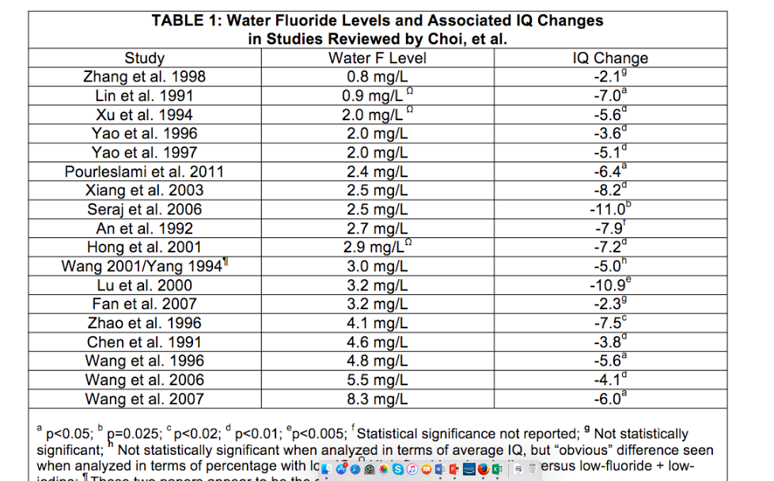

In the Xiang (2003) study discussed above (which was one of the 27 studies reviewed by Choi, 2012) IQ was lowered at 1.53 ppm, and possibly at 0.75 ppm. These findings provide no margin of safety for those children drinking water in NZ at 0.7 or 0.85 ppm (see table 8 in the Xiang paper, printed below).

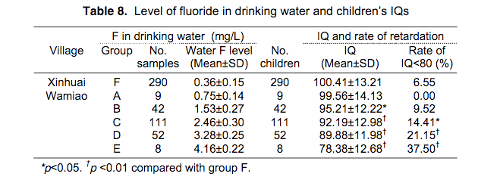

http://www.fluorideresearch.org/362/files/FJ2003_v36_n2_p84-94.pdf

(if this link doesn’t work, please copy and paste into your search engine)

This important table needs further clarification. Most of the 27 IQ studies reviewed by Choi et al (2012) had a simple design. They compared the mean IQ in a high-fluoride village with the mean IQ in a low-fluoride village. However, Xiang et al went further; they sub-divided the high-fluoride village into 5 sub-groups (of ascending fluoride concentrations) and thereby revealed two important dose-response relationships.

- As the fluoride concentration in the sub-groups goes up (A-E) from 0.75 to 4.16 ppm the mean IQ in the sub-groups goes down from 99.86 to 78.38 and 2) As the fluoride concentration in the sub-groups (A-E) goes up from 0.75 to 4.16 ppm the percentage of children in each sub group with an IQ less than 80 (which combines borderline mentally handicapped with outright mentally handicapped) goes up from 0 to 37.5 %. These dose-response relationships are illustrated in the figures below (reproduced from Hirzy et al., 2016)
- Note these relationships are found in the high-fluoride village – and thus are not influenced by any factor that varies between the two villages.

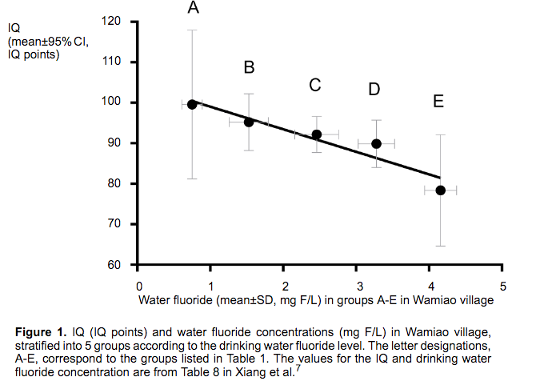

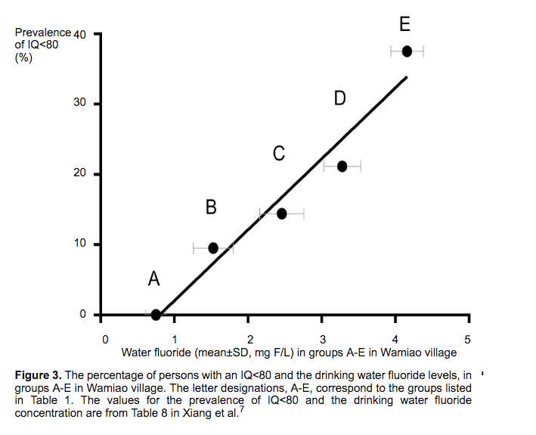
It was the first dose-response relationship which was used in the EPA petition and in our paper (Hirzy et al., 2017) in a Benchmark Dose Analysis to determine the startling fact that a daily dose of 1.4 mg/day lowers the IQ of children by 5 IQ points. See the graph in the figure below:

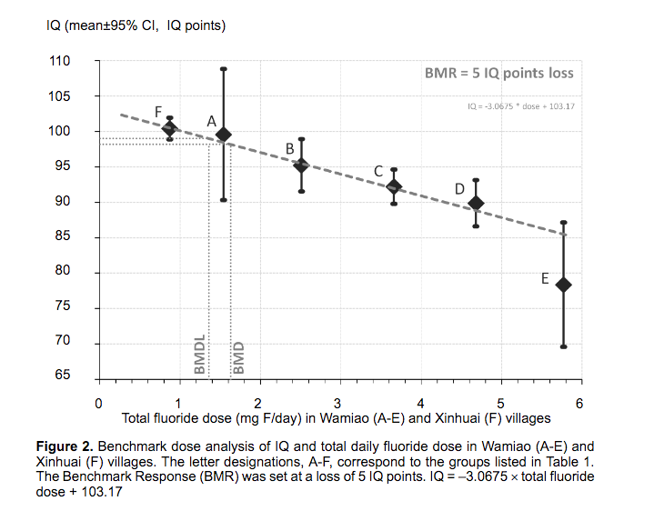
Note in the graph above (Figure 2, from Hirzy et al., 2017) that the BMDL (the Benchmark Dose Level) line (set at a loss of 5 IQ points) cuts the x-axis at approximately a fluoride dose of 1.4 mg/day. This is the startling determination referred to above.

Conclusion

This is the worst possible time to expand the fluoridation program in NZ. With the ever-increasing body of evidence that fluoride is neurotoxic and can lower IQ at doses exceeded by some NZ children – especially the most vulnerable – it is time to end this practice forthwith, and look for other ways of protecting children’s developing brains from fluoride. Meanwhile, the Ministry of Health should investigate programs in Scotland (the Childsmile program), Denmark (the Nexo program) and other non-fluoridated countries, that have lowered tooth decay cost-effectively (including among low-income families) without forcing fluoridation on the whole population. Programs that stress the importance of diet – especially lowering sugar inputs – not only help to fight tooth decay but also help fight obesity. One of the reasons that they are cost-effective is that with early interventions with parents it dramatically reduces the incidence of baby bottle tooth decay (BBTD) which often lead to expensive extractions in hospitals under anesthesia. I described these programs in more detail in my power point presentation last year in Christchurch see https://www.youtube.com/watch?v=GA9F5J93UVw

I would like to testify before your committee either in person or via skype.

Paul Connett, PhD
Professor Emeritus of Chemistry,
Co-author of The Case Against Fluoride
Senior advisor of the Fluoride Action Network (USA)

References

Broadbent JM, Thomson WM, Ramrakha S, Moffitt TE, Zeng J, Foster Page LA, Poulton R.
2015. Community water fluoridation and intelligence: Prospective study in New Zealand. American Journal of Public Health 105(1):72-76.

Broadbent JM, Thomson WM, Moffitt TE, Poulton R. 2016. Broadbent et al. respond. American Journal of Public Health 106(2):213-14.

Choi AL, Sun G, Zhang Y, Grandjean P. 2012. Developmental fluoride neurotoxicity: a systematic review and meta-analysis. Environmental Health Perspectives 120(10):1362-8.

Hirzy JW, Connett P, Xiang Q, Spittle BJ, Kennedy DC. 2017. Developmental neurotoxicity of fluoride: a quantitative risk analysis towards establishing a safe daily dose of fluoride for children. Fluoride 49(4 Pt 1):379-400. Available online, http://www.fluorideresearch.org/494Pt1/files/FJ2016_v49_n4Pt1_p379-400_pq.pdd

Li XS. 1995. Effect of fluoride exposure on intelligence in children. Fluoride 28(4): 189-192. Full study at http://www.fluoridealert.org/wp-content/uploads/li-1995.pdf

Osmunson B, Limeback H, Neurath C. 2016. Study incapable of detecting IQ loss from fluoride. American Journal of Public Health 106(2):212-3.

Spittle B. 2014. Fluoride, IQ and advice on Type 1 and Type II errors. Fluoride 47(3):188–190. Editorial. Available online, http://www.fluorideresearch.org/473/files/FJ2014_v47_n3_p188-190_sfs.pdf

Wang QJ, Gao MX, Zhang MF, Yang Ml, Xiang, QY. 2012. Study on the correlation between daily total fluoride intake and children’s intelligence quotient. Journal of Southeast University (Med Sci Ed) 31(6):743-46. (Translated from Chinese into English by Fluoride Action Network in 2016.)

Xiang Q, et al. 2003a. Effect of fluoride in drinking water on children’s intelligence. Fluoride 36(2):84-94. Full study at http://www.fluoridealert.org/uploads/xiang-2003a.pdf

Xiang Q, et al. 2003b. Blood lead of children in Wamiao-Xinhuai intelligence study. Fluoride 36(3):198-199. Full study at http://www.fluoridealert.org/uploads/xiang-2003b.pdf

Zhao LB, Liang GH, Zhang DN, Wu XR. 1996. Effect of high-fluoride water supply on children’s intelligence. Fluoride 29(4):190-192. Full study available at http://fluoridealert.org/wp-content/uploads/zhao-1996a.pdf

