02-02-2017

The Chairperson,
Health Committee,
Parliament Buildings,
WELLINGTON.

Submission on the Health (Fluoridation of Drinking Water) Amendment Bill

Arguments Against Changing the Decision Making Responsibilities
from Local Councils to DHBs

- What is wrong with the Health Amendment Bill (fluoridation of drinking water)?
This Bill gives District Health Boards total power to make decisions and give directives to local Councils to fluoridate without consultation, without population monitoring and without individualised assessment or informed consent, and behind closed doors. There is:

- NO community consultation requirement (Note: the original LGNZ remit was not intended to remove community input)

- NO requirement for the implementation and ongoing costs to be covered by the DHBs

- NO requirement for the provision of fluoride-free public taps or water sources

- NO op-out provisions for people who are sensitive to fluoride

- NO informed consent required from the people in the community

- NO provisions for communities like Napier, Nelson and Christchurch to be able to continue to be non-fluoridated. The Bill is also designed to make it virtually impossible to stop fluoridating in currently fluoridated areas

- NO choice: If a local authority disobeys a directive to fluoridate, they would face penalties of up to $200,000 plus $10,000 per day of non-compliance. The fines also apply to local authorities who are already fluoridating and wish to discontinue

- NO democracy: The financial penalties were deemed to be necessary in order for DHBs to be able to ENFORCE THEIR POWERS when directing local councils to fluoridate
- NO requirement for DHBs to consider the financial costs of kidney, diabetes, thyroid, obesity and other population health costs against the financial costs of fluoridation. Their only requirement is to compare the financial costs against the dental health costs

- NO full assessment of all the available fluoridation information is required, only what the Ministry of Health wants the DHBs to see (which is mainly misinformation, statistical myths and incorrect science – see below)

- NO informed decision making required. Giving responsible advice on fluoridation safety surely requires a fully detailed analysis of the huge amount of reputable scientific data available?

- NO assessment required of the health impact on subsets of sensitive populations e.g. kidney, thyroid, arthritis , babies or elderly patients

- NO mention that hospitals can opt out by having their own non-fluoridated water supplies to support the recovery of their patients. Patients will not be required to give informed consent as to whether their drinking water is fluoridated or not

- NO requirement for population monitoring to assess the accumulation of fluoride in teeth, bones and pineal glands over time

- NO requirement for DHBs to look at successful non-fluoridation options of reducing dental decay - such as through ‘Water Only No Sugar’ policies in schools, the Childsmile program in Scotland and the Nexo programme in Denmark

- NO way for citizens or councils to know that a DHB has made a decision to fluoridate until AFTER the decision has been made

- NO way for citizens or councils to be able to afford the only method of challenging a DHB decision – which can only be by Judicial Review

- NO unanimous agreement by all councils on the original LGNZ remit

- NO intention by the LGNZ to necessarily increase fluoridation, merely to provide a better platform for decision making

- The Science is Not Settled
It is a fact that New Zealand's top policy-makers and public health officials are ignoring and/or denying valid evidence, produced by experts in their fields and respected science groups, showing that fluoridation science has not been settled.

I argue that the policy makers themselves do what they accuse fluoridation opponents of doing. The policy makers routinely share only partial, biased information in order to support their case, and convey information in terms that misrepresent the actual situation. This equates to a blatant ongoing dishonesty, perpetuated in order to protect policy and save face at all costs. In this case – unfortunately the costs are human costs.

- Some studies, including recent ones, show no benefit from fluoridation; some report adverse effects - but all these studies are completely ignored by our officials.

- For example in 2015 the Cochrane Review "concluded that there is very little updated and high-quality evidence indicating that fluoridation reduces dental caries, while there is significant association between fluoride levels and dental fluorosis [discoloured teeth]." However, this conclusion has been completely ignored by the MoH.

- In our current situation with this Bill, both the Select Committee and the DHBs are being steered by the Ministry of Health to only consider the 2009 NZ Oral Health Survey - rather than the much more comprehensive data that is readily available.

- The information to back up the MoH claim of a 40% reduction in dental decay comes from the September 2015 Sapere Report (“Review of the benefits and costs of water fluoridation in New Zealand”), which in turn rests on the 2009 New Zealand Oral Health Survey. This survey is the most unreliable piece of data that could be used to ascertain the effectiveness of fluoridation - but it is used by the MoH because it suits their pro-fluoridation-at-all-costs agenda. (The 2009 Oral Health Survey had a small sample size - only about 60 children in each age group and unknown life-time exposure. In comparison, the New Zealand School Dental statistics are collected every year and have about 45,000 children in each age group.)

- Instead the MoH could have looked at the two NZ studies from 2008 and 2009, prior to the Oral Health Survey, which both looked at lifetime exposure to fluoridation and compared children of the same age in the same area. If they had done so, they would have found no difference in decay rates but instead a doubling of dental fluorosis.

- “Enamel defects and dental caries in 9-year-old children living in fluoridated and nonfluoridated areas of Auckland, New Zealand”. Kanagaratnam S, Schluter P, Durward C, Mahood R, Mackay T. 2009. https://www.ncbi.nlm.nih.gov/pubmed/19302574

- “Prevalence of enamel defects and dental caries among 9-year-old Auckland children”.
Schulter PJ, Kanagaratnam S, Durward CS, Mahood R. 2008
NZ Dental Journal December 2008 (p145-152)

- Alternatively, the MoH could have used the NZ study published last year by Philip J. Schluter and Martin Lee in Bio Medical Central Oral Health (“Water fluoridation and ethnic inequities in dental caries profiles of New Zealand children aged 5 and 12–13 years: analysis of national cross-sectional registry databases for the decade 2004–2013”). This study, using the Ministry of Health’s own oral health statistics, showed dental health improved to the greatest extent for children in non-fluoridated areas.

- Very tellingly, the most recent study on specifically just Auckland children's dental health, published in January 2017, also shows there is no substantial difference in decay rates between children living in fluoridated or nonfluoridated areas. If anything, children in the nonfluoridated areas are doing better. It also shows that children in fluoridated areas have slightly more severe decay, with more children needing a large number of fillings. (“The effect of community water fluoridation on the incidence and severity of tooth decay in 31,720 Auckland children” Dr Stan Litras BDS BSc) Download full-text PDF here

- On the other hand, the MoH could so easily just have used the NZ School Dental Statistics themselves (see graph below), which clearly show non-fluoridated areas often have better dental health than fluoridated ones because, in truth, the biggest predictor of dental health is socio-economic.

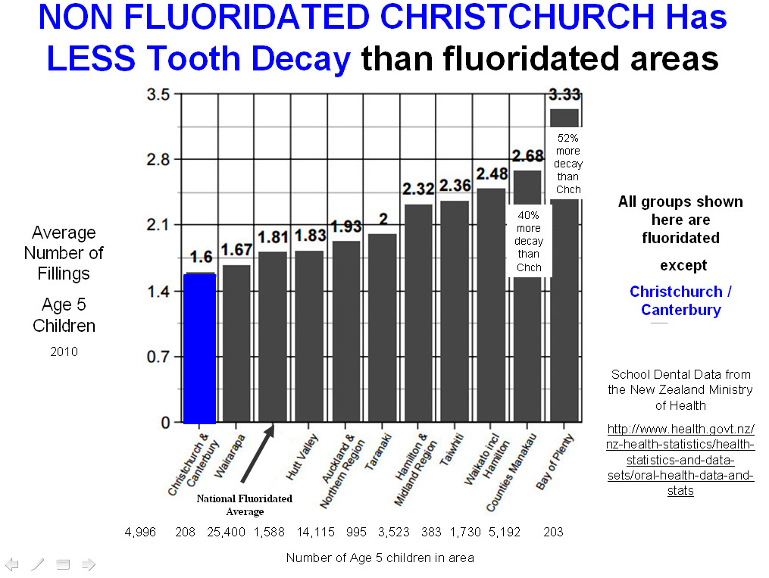

I strongly oppose the new Bill and encourage the Select Committee to nullify the current proposal. I urge that fluoridation immediately ceases in NZ. I wish to speak to my submission.

Pat McNair
Fluoride Free Hamilton

